## Prototypes, design, details

It was clear from the start that we are entering a new area for us as programmers, yet a well-known for us as end-users as we do have smart phones and we use app on those devices.

Luckily we have had some useful design courses at the FHNW which gave us a good base to start with as we knew from the start that offering the users an user experience (UX) experience while dealing with the app should be our top non-functional requirement to fulfill, considering the beauty aspect while designing the elements.

After we have defined our persona, we thought that it is time to decide which information or screens flow and sequence make sense the most to the end user and what would the user expect to see in an event app.

So we have started by doing some paper sketches, and as the main feature in an event app is to search for events, we have considered making this feature on the home screen as the first feature to interact with as the user launches the app.

Figure 3 Home screen first concept

The idea was that the user shall click on the arrow down to open a hidden small page at the bottom of the search event header, in which the user would enter the search query data as follows.

Figure 4 search for event

After entering the search criteria the user must click on search so that a new screen opens which contains the search result in a table as shown below.

Figure 5 Search result table

Tapping on one of the results shall open a new screen with the selected event details as shown below.

Figure 6 event details page

And the same applies to the other header contained in the home screen regarding the other features, while clicking on the profile icon on the top right would open the profile screen and the burger button on the top left would open a menu which contains information about the app version and the language used as it is required from the client that the app must support two languages.

Afterwards we have shown a sample of the end-user those designs and their feedback was that they would rather have different screens for the features, and not all in one screen.

At that point we knew that we need to use buttons on the main screen, but what was challenging is how to place them in the main screen without violating the beauty or user experience of the apps elements.

In order to figure that out, we have done a research about the apps that offer a similar service like Swiss Engineering Event App should do, and although there were not many, yet we knew the correct one as soon as we saw it.

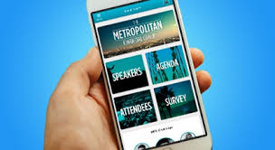

Figure 7 Event App Home Screen

This design’s distribution of the elements shown above matches exactly what we had in mind while searching. The Buttons in this case adds even more beauty to the design overall because of the beautiful color and the masking that the developer has done to the photos used.

So in order to implement this design, a color must be chosen. Unfortunately the color used in the Swiss Engineering logo to represent their identity is the red (#FE0101) which is a bright the degree of red that distracts the end-user and should not been used much in elements.

According to Google design guidelines and also [Xamarin University](https://www.youtube.com/watch?v=hP5lHjCvIu8&list=PLiYxFUr7iw9NHX4hVGoxtkHCT4bcgpnm_&index=2&t=2934s), the Brand color must be defined as well as two different degrees, one must be lighter and the other darker. So We have applied the same rule in our design and ended up with a beautiful degree of red that the end user did really love which is the Red (#AF4444).

Figure 8 Red #FE0101

Figure 9 Red #AF4444

After deciding the main color to be used and represent the identity of the organization behind the app, we decided that it is time to jump to Sketch and start designing Hi-Fi prototype, but because we were not sure that the end-user will find the degree of red chosen comfortable, we designed five candidates for the home page with five colors, and taken one of our personal favorites to design the whole app with to get the user feedback about the app logical sequence, information flow and distribution.

Figure 10 Home screen candidates

Although one of our personal favorites was the Dark theme, yet according to our survey and questionnaire that we have conducted, the sample of the end-user that we have tested the designs with have chosen the red filled buttons at the far left. That was a good sign for us as it showed that the degree we have chosen was suitable for the app and doesn’t distract the end-user as we thought.

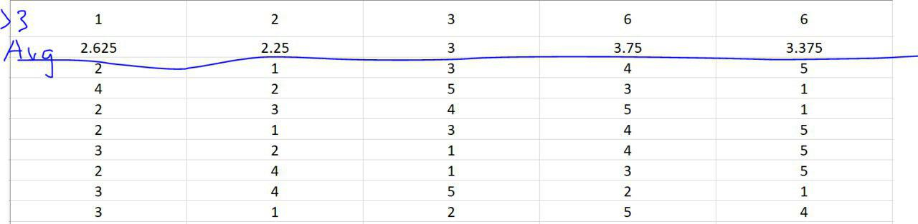

Figure 11 the result of the survey for the five candidates with the same sequence oft he previous photo

Figure 12 first Sketch design tested with the end user sample

If we kept the color aside, and that is what we have asked the end-user to do, what is your overall rating of the elements used, and how hard is it to get the following tasks then, then we asked them to search for events, and delete tags and save searches. Talk to Seea was not yet included in the design because we knew that it shall not be used to search for events as almost 100% of the end-user sample said that they would rather use the normal text entry way than searching for events by voice.

The end-user has the feeling that the home page is somehow empty, and they were expecting more layers instead of a single ton layer which was black in our design.

They have found also the text fields to be somehow old fashion design and some of them. Although no end-user found problems saving the search, but many advised to change the star sign, without the text “Save” under the star they wouldn’t have guessed that this start would save the search criteria entered.

The same feedback about the emptiness and the one layer tone of color comes over with every screen that contained a table.

The designer did heavily criticized the event details page, he didn’t like the placement of the photo, as well as the buttons of driving to event and save to calendar. It is worth mentioning that 3 end-users did have difficulty reading the text inside those two buttons.

After gathering all of those feedback it was the right time for us to create the light theme design while including all the gathered feedback and addressing all the issues in it.

We did solve the one layer of color tone by taking the approach that all other well apps do, which is sticking another layer to include the content with a lighter color than the one used on the big background, for example the white stickers on top of the grey background like it is done natively on iOS system.

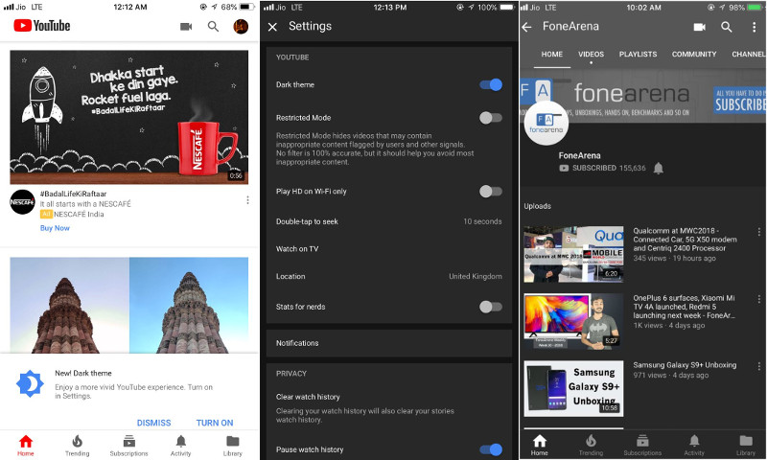

Figure 13 Youtube dark grey layer on top of the black background

Figure 14 Alex Pesenka Perfume Pyramid design

Figure 15 Facebook news feed

Figure 16 iOS UI

Figure 17 Samsung ONE UI

Figure 18 SBB Home screen

Figure 19 SBB text input style

So after revisiting all of those apps (now with a designer’s eye) we have decided to use the grey (#E5E5E5) as our background color, which the same degree of grey used on the iOS UI.

For the sticker layer which the element will be placed on we have decided to use the brightest degree of white (#FFFFFF) to create the familiarity feeling between the end-user and the colors as this combination is used heavily in multiple of widely known apps and operating system.

The text entry will now be inspired from the SBB app. The reason for that, is that as we have defined our persona to be a swiss or a swiss resident, then the persona must be familiar with the SBB app, or at least have used it once. So using their text entry style will not add the modern factor to the app but also the UX which we seek. Instead of the star sign a normal Radio button will be used with the label save search to indicate what does the button do.

The tables background will be also white on all screens, and useful meaningful icons are going to replace the one that were somehow misleading.

The design that we ended up with is shown in the following image, with dark elements to construct the dark theme but while keeping all design elements and layers on the same distribution to not violate the consistency of the two themes and also maintaining the same level of the UX between both themes.

Talk to Seea screen was presented in this version, it contains chats bubble that the end-user normally uses daily on the different platforms like SMS apps and Whatsapp. It is worth mentioning that the text box as well as the apps were designed specifically for Swiss Engineering event app from scratch, the reason for that is that we couldn’t find suitable bubbles to what we have in mind in order to represent the modern design school. The user can click on the mic icon to turn the voice assistant feature on or off, while it shows a suitable meaningful icon for the action.

Figure 20 Light theme before coach feedback

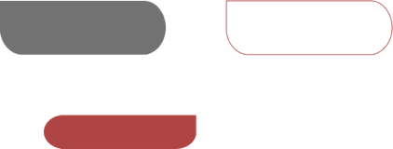

Figure 21 Chat bubbles

The Table’s cells contains an arrow, the function of this arrow is to indicate that clicking on this cell will navigate the user to another screen.

The event details page contains all the details in a white table with the header of the event on the top and the book now button on the bottom. The image is now masked to fit the whole width of the screen instead of placing it in the center, and the buttons to drive the end user to the address or adding the event into the end-user calendar app are now included in the table, with no visible buttons but only two icons to indicate what clicking on them would do, we counted here on the UX as those symbols or icons are known for those two functionalities.

The last change that we have done although it might look minor, but in the design it is big, which is changing the font family used, which was Roboto in the first design, and in this second design it is Lato. The reason for this change is the advice of the designer that we have tested the app with before.

After making all of those changes, we have tested the new app with a sample of the end-user and their feedback was much better than before.

Afterwards we have sent the design to the coach to get feedback and we have received it in return.

Because Swiss Engineering App contains a lot of tables, the design seemed to be static a bit, and also for some fields, it was not that clear if the field is clickable or not.

We have made some changes by adding a layer of the red color that we have used in the home screen into the tables a layer each individual event in the Get inspired scree. Also we have got a new design idea for the same screen from Facebook market place, by splitting the table into categories, each with its own white sticker, at the top of each we have added the reason why is this event suggested as a header.

We have also changed the Reserved Events table by grouping the events reserved on the same date together with the date on the top of each group as a header and a grey line to separate the dates.

To separate the events booked on the same day from each other we have used our main red color degree as the background color of each event with white text. This idea is normally used by the calendar apps, Google Calendar for instance.

We had the meeting with the clients who liked the design in general, but gave us some feedback regarding the quantity of the red elements used, the icons used to represent the functionality of take me to event or save event to the end-user’s calendar and also the Get Inspired screen, in which the user shall be able to remove the tag from there without navigating to the profile screen.

So we had to visit once again the apps we previously mentioned to know how did they exactly handled those issues.

For starters we have designed the Event details screen in a way to keep it as clean and as organized as possible, and in order to do that, we had to drop the Event Description field and use a hyperlink instead, which the user can click to navigate to the event description page on the Swiss Engineering platform.

The reason behind this decision is that the event description contains a lot of text which can take over multiple screens if displayed fully, so even creating a new screen for it which opens if the user clicked on the event description won’t solve the problem. But the client requested that the event description shall be included in the same event description page with no links, thus we re-arranged the order of the event fields to keep the description shown at last, with a scroll bar on the right side to indicate that the table is scrollable. We pinned the button Book Now also to the bottom, so it is visible no matter how far did the user scrolled down.

Then we removed the liked tags from the profile, which the user might click on and edit the tags liked, and used instead three dots like the Facebook Marketplace beside each header, the user might click on those three dots then decide whether to delete the tag from the liked tags list, or even show all the events that are included under this tag.

Last but not least to solve the color issue we had to use the inverse color (Accent color) of the main color, which is the technique that most of the well-known apps also use. But in our case because we didn’t use the bright Red color of the Swiss Engineering logo, we used the inverse color of our own Red that we have chosen, which ended up being a better decision because the inverse color of the Swiss Engineering logo is also so bright and not even comfortable to look it. The Inverse is used in the third version is the Cyan (#50BBBB).

Inverse

Figure 22 Cyan #50BBBB

Figure 23 Red #AF4444

We ended up using this color for almost all elements that are clickable, except the home screen, but not as text color because it made it harder to read the text for the end-user especially in the light theme, instead as the background color for all clickable icons and elements, for instance the arrows of drop down menu and navigate to new screen, the new save heart which is Ricardo.ch technique to save items, the turn off and on radio buttons as well as the indication of selecting cells of the Saved Searches table.

What the Cyan color indicating is that this cell or element is clickable, but clicking it will not invoke a main function, for instance it will now search for events, delete events, booking or even saving them, yet it selects the elements, show small screens inside the main screen the end-user is in or navigate the end-user from screen to screen.

We ended up also using the Cyan color for the Radio Buttons to indicate that they are turned on while keep using the grey for turned off buttons to not violate the UX rules.

The Dark theme can now also be turned on or off in the Profile screen, and the saved searches in the Saved Searches screen have now a magnification lens icon to indicate that this entry is a search criteria entry, and if the end-user wishes to edit the saved searches, the edit button on the top left must be clicked first to start selecting which searches records to delete by clicking then on the trash can icon.